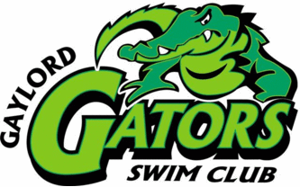
2020/2021 Sponsorship Levels/Benefits:
Please fill this form out completely and mail to P.O. Box 2014 Gaylord, MI 49734
Sponsorship Name: __________________________________________________
Address: _____________________________ City: _____________________
Contact Person: _____________________________ Phone: _____________________
Authorizing Signature: ____________________________________________________
Swimmer Sponsor
- Swimmer will acknowledge business
- Swimmer will provide Thank-You

Freestyle Program Sponsor $250
- Business Name in a Home Meet Program
- Framed Team Picture for Your Office Display
- Sponsorship Certificate
- Team signed Thank-You

Butterfly Meet Sponsor $500
- Business Name in EVERY program for each Home Meet
- Ad on Gators Facebook Page
- FREE Admission to Home Meets and a Bake Sale Treat
- Framed Team Picture for Your Office Display
- Sponsorship Certificate
- Team signed Thank-You

Ultimate 500 Meter Team Sponsor $1000
- Business Name in EVERY program for each Home Meet
- Ad on Gators Facebook Page
- Large Business Banner Displayed during Home Meets
- FREE Admission to Home Meets and a Bake Sale Treat
- Framed Team Picture for Your Office Display
- Sponsorship Certificate
- Team signed Thank-You

(The Gaylord Gators is a non-profit 501c (3) organization as defined by the IRS. Donors may deduct contributions as provided in section 170 of the tax code. Gaylord Gators Tax ID #38-3362861)

